The effect of social expenditures in deterring violence from organised crime in Mexico



Candidate Number 1028684

Department of Social Policy and Intervention

University of Oxford

Word Count without tables and references: 9,974

Total word count (including appendices, tables and references): 12,986

A thesis submitted for the degree of

**Master of Science in Evidence-Based Social Intervention and Policy Evaluation**

2018-2019

# Abstract

Conditional Cash Transfers have been used in Mexico since 1997 to try to break the intergenerational poverty cycle. However, as an unintended consequence of its original design, they might have had a deterrence effect in violence by offering minimum conditions to prevent the most vulnerable populations from joining criminal organisations. Using a fixed-effects model, the objective of this research is to assess the impact of having a greater or lesser number of beneficiaries of PROSPERA, the most important poverty alleviation strategy in Mexico for the past 21 years, in the number of homicides by each municipality. The main conclusions of the analysis are that previous to the war on drugs, a greater number of beneficiaries of the main social programme in Mexico was related to a protective factor against homicides. Considering the increase in the homicides after 2007, overall throughout the period 1998-2017, for every 1% of households of the municipality joining the programme, there was a reduction of 0.52 homicides per 100,000 inhabitants. However, if we divide the period before and after the military interventions, the effect is no longer significant and is even negative for municipalities with a higher presence of criminal organisations. Despite such negative effects after the war on drugs, recent data seems to show that social expenditures were recovering its protective factor after 2015, although more data is required to confirm the effect.

# Introduction

Prevention strategies to reduce homicides seek to address the root causes of the problem instead of just targeting its consequences. Hence, these approaches aim to be sustainable in time by addressing the risk factors that lead to the involvement of the population in criminal activities. There is a large body of evidence assessing the effects of social expenditures in different types of crime and violence, especially in high-impact crimes such as homicides, mostly in the United States (Sampson, 1987; Chamlin et al., 2002; Worrall, 2009) but also through cross-national comparisons (Fajnzylber, Lederman and Loayza, 2002; Rogers and Pridemore, 2013; McCall and Brauer, 2014).

Various mechanisms in the literature explain the link between social protection and criminal activity. Social disorganisation theory, for instance, states that impoverished communities with high levels of ethnic heterogeneity, residential mobility and family disruption cannot exert social control over the behaviour of its members, deriving in increases in crime and delinquency (Sampson and Groves, 1989). Other theories, in turn, state that market societies do not offer adequate social protection from economic changes, creating a hard culture that focuses in materialistic gain, which makes their population more prone to crime (Currie, 1997). In any case, social expenditures would offer a safety net to reduce the relevant factors of social disorganisation theory through the provision of family assistance, unemployment or market protections or by offering State support to face adverse economic or social events, increasing the opportunity costs of joining a criminal organisation (Rogers and Pridemore, 2013).

However, the research conducted so far tends to focus on contexts of gang violence or general levels of criminal activity that might differ from the characteristics of organised crime. Some of the contrasts between organised crime and gang activity include the level of criminality, planning and control (HM Government, 2013) which can be arranged in a continuum of the level of sophistication and organisation (Smith, Rush and Burton, 2013). Despite the importance of analysing the differences between gang-related violence versus that generated by organised crime, there is no sufficient evidence regarding the impact of social expenditures in contexts where organised crime operates.

To shed light on the issue, I will analyse the case of Mexico, where the presence of organised crime and a war on drugs conducted by the government have increased the number of homicides from 8,867 in 2007 to 31,174 in 2017 and continue to rise, according to figures of its national statistical office (INEGI, 2019). To assess the social expenditures, I take advantage of the public information existing on its main strategy to fight intra-generational poverty in the last 20 years, PROSPERA (previously Oportunidades and PROGRESA), which, before 2019, used to operate as a conditional cash transfer.

In this regard, the research question that this thesis will answer is, do municipalities that have a greater proportion of beneficiaries of PROSPERA in Mexico have a deterrence effect in homicide rates compared to those that have a smaller proportion regarding their entire population, before and after the war on drugs? By addressing this question, I should be able to offer recommendations for the new policies that are being implemented in Mexico as primary prevention strategies to address violence and social protection. My research also contributes to the academic debate by complementing previous analysis that did not take into account the period of greater expansion in the violence problem in Mexico and contribute to the general literature on the impact of social expenditures in homicides by addressing the specific variation from a model of general crime to a direct armed confrontation between drug trafficking organisations and the State.

# Background

Since the declaration of the war on drugs, Mexico faces a deep challenge concerning violence caused by drug trafficking organisations. However, the preventive strategies implemented so far have not offered promising results. For instance, Garay and Díaz Román (2017) found that, contrary to the expected effects, the municipalities that received the interventions from the National Programme for Crime Prevention during the 2013-2018 administration reflected a statistically significant increase in their homicide rates.

The importance of knowing what works in terms of prevention strategies to address criminal activities in Mexico is even greater if we consider that the main strategies rolled out by the new government have not been tested or evaluated in their design. Their focus mainly is to improve the population socioeconomic conditions through direct cash transfers (for an initial discussion of the social policy in López Obrador’s administration see Cejudo, 2019). For instance, the main strategy announced to link young unemployed people in Mexico to productive activities is the programme *Young people building future*, which in 2019 received a similar budget to the main strategy to fight poverty in the past four administrations, PROSPERA. The aim of this novel strategy is to offer direct money transfers to the targeted population in exchange of attending job training sessions with an enterprise, giving priority to young people living in areas with majoritarian indigenous populations, deprivation levels or high violence rates (Guidelines for the operation of the Programme Young People Building Future, 2019*)*.

An advantage, though, of focusing on Conditional Cash Transfers (CCTs) is that we can learn from previous strategies that can offer important insights regarding the adequate implementation of the policy. This does not mean that the new strategies should not be evaluated, thoroughly diagnosed or even piloted to at least minimise the possibility of having no effect or even negative effects on the targeted populations. However, the new policies do not have to start from scratch, since they have the implementation experience of one of the first CCT Programmes in the world, PROSPERA.

## PROSPERA

From 1997 to 2019, PROSPERA operated as a CCT that offered monetary transfers and in-kind benefits to poor and extremely poor households, particularly to mothers, linked to regular school attendance of their children and health checks. In this regard, the programme focused on improving the human capital of its beneficiaries by addressing three main components: education health and nutrition (for a more detailed account of the main features and evolution of the programme see Dávila, 2016). More recently, the programme that began with the name of PROGRESA and then Oportunidades changed its name to PROSPERA and included a fourth component regarding social and productive inclusion of its beneficiaries. Nevertheless, in 2019, the health, nutrition and productive inclusion components of the programme were removed from its design (Guidelines for the operation of the Programme PROSPERA, 2019). In this regard, PROSPERA was transformed substantially from being a CCT to only operate as a scholarship programme focused mainly on supporting high-school levels and focusing on linking the recipients of the scholarship with other strategies of the Government such as the programme *Young people building future*,already discussed.

Unlike other CCTs, such as Bolsa Familia in Brazil, the programme incorporated impact evaluations within its design and has shown consistently positive results in several measures of human capital such as reduced child labour, higher consumption levels, school enrolment rates, improvements in children height, completion of more years of schooling, among other categories (Fiszbein and Schady, 2009). Despite its favourable results, one of its criticisms was that practically there were no differences in the types of jobs and wages earned by beneficiaries and non-beneficiaries of the programme (PROSPERA, 2017b). However, a more recent evaluation conducted by Parker and Vogl (2018) showed that regarding the long term impacts of the programme, educational attainment increased by 1.33 years for men and women, increased women’s probability of working by 41% and women’s labour earnings by 65%, despite not finding significant differences in men’s earnings.

Despite PROSPERA’s main objective was not directly related to violence, the causal mechanisms proposed for the new policies in generating social cohesion, offering a minimum income to avoid having to look for illegal sources of revenue and offering a set of skills to have better chances of getting jobs are present within the programme. Therefore, if the assumptions of the new interventions are true, we should be able to see at least an indirect effect of PROSPERA in deterring criminal violence across Mexico. However, by analysing at least the last year of available data on homicides and PROSPERA’s beneficiaries shown in figures 1 and 2, we can spot a slight but probably relevant positive relationship between the number of beneficiaries and homicides per municipality that is worth analysing with more depth.

**Figure 1. Number of beneficiaries of PROSPERA per municipality, 2017**

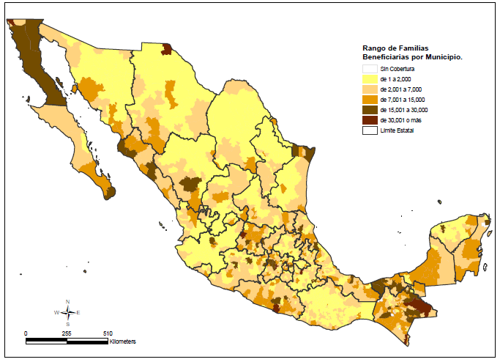

**Range of families beneficiaries by municipality**

No program coverage

1 to 2 ,000

2 ,001 to 7 ,000

7 ,001 to 15 ,000

15 ,001 to 30 ,000

30 ,001 or more

State limit

Source: PROSPERA, 2017a.

**Figure 2. Number of homicides per municipality, 2017**

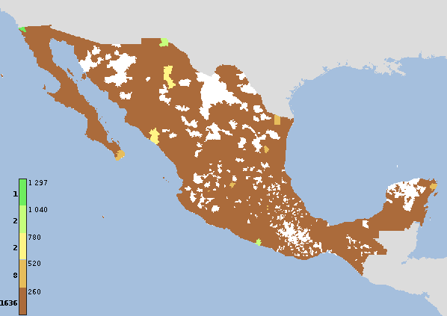

Source: INEGI, 2019

## Violence context in Mexico

During the 1990s, violence in Mexico – decreased 25.92% if we consider the homicides reported in 1990 and 2000. However, as figure 3 shows, the number of deaths by homicide suffered a sudden increase after 2007, shifting from a level of 8,867 in 2007 to 31,174 in 2017, an increase of 251.57%, considering only a direct comparison between those years. Various authors have offered different explanations for the phenomenon (see Zepeda, 2018 or Pérez, 2015 for a classification). The theory that concerns most to this research is the one regarding social protection, since it explains the causes of the increase in homicides and focuses on the presence of a social net to offer a minimum base of wellness that increases the opportunity costs of joining a drug trafficking organisation.

Source: INEGI, 2019

Brito, Corbacho and Osorio (2014) compare the proportion of household receiving remittances from migrants in the United States at a municipal level with homicides per 100,000 inhabitants. Their results show that every percentage increased in the proportion of household receiving remittances reduced the homicide rate by 0.05 per cent. Also, according to Enamorado, López-Calva, Rodríguez-Castelán and Winkler (2016), inequality is an important factor that explains violent crime in Mexico. The authors found that a one-point increase in the Gini Coefficient during the years of the war on drugs in Mexico could explain a 36% increase in the number of homicides per 100,000 inhabitants related to drug trafficking.

In this regard, it appears that in general, there is a relevant role of social protection regarding poverty and inequality towards deterring homicides. As evidenced by Pérez-Correa and Azaola (2012), the offenders that end up in jail tend to come from tough socio-economic contexts. However, as Chávez Villegas (2018) found by analysing surveys and interviewing young drug male offenders, the poverty experience of the interns tends to be heterogeneous, which can be affecting the effectiveness of social protection measures.

While the aforementioned theories would guide the analysis of the current research, it is necessary to consider alternative explanations to the levels of violence that Mexico faced after 2007. One of the main alternative explanations due to the amount of evidence gathered and the use of strong quasi-experimental designs relates to the police and military interventions that initiated in December of 2006 with the joint operations to fight organised crime. Escalante (2011) was one of the pioneers in signalling that the military interventions might have created counter effects as those intended, by showing that the states were the federal government conducted joint operations with the military, navy and federal police had a dramatic increase. His findings were tested and confirmed through the application of more robust methodologies by Merino (2011) or Espinosa and Rubin (2015), who used propensity score matchings. Resa (2017) contributes to the analysis by showing that the military interventions obeyed to an increased rate in homicides, instead of being the source of the violence.

A second factor that has been pointed out in the literature as contributing to the sudden increase in homicides is the conflict among cartels. These types of explanations mention that the cause of the increase in homicides is the fight among criminal groups, already in place even before the first joint operation (Zepeda, 2018). Coscia and Ríos (2012), for instance, analysed indexed newspapers and blogs to assess the presence and operation of criminal organisations in different municipalities explaining increased levels of violence in certain regions. Calderón et al. (2015) used a synthetic control to compare the number of homicides after the capture or killing of kingpins and determine that the high profile strategy has led not only to homicides related to drug trafficking but also to homicides affecting the general population. Finally, Rivera (2015) analysed the interaction between competition among cartels and military and bureaucratic state capacity to show that competition among a small number of criminal organisations, and intermediate state capacity produce the highest rates in homicides.

## The effects of social expenditures on homicides

As already mentioned in the introduction, there are diverse studies that relate social expenditures with crime rates. Although there is variation in types of crime analysed, the general trend is that there is a negative relationship between both variables. For instance, Worrall (2009) analysed California counties from 1990 to 1998 observing a significant inverse relationship between homicide and expenditures in General Relief, a local programme conceived to support adults who cannot apply to Federal or state social support. Fajnzylber, Lederman and Loayza (2002) reached a similar conclusion while analysing the determinants of intentional homicide and robbery rates for a worldwide sample of countries during the period 1970-1994. In general, they found that economic growth and income inequality are good predictors of violent crime rates.

More particularly, regarding the relationship between CCTs and homicides, we find mixed evidence that requires further research to be assessed. On the one hand, Chioda, De Mello, João and Soares (2013) analysed the impact of Conditional Cash Transfers on crime in Sao Paulo, Brazil and they found a significant effect of *Bolsa Familia* on crime reduction. On the other hand, however, Loureiro (2012) did not find evidence of effects of CCTs in homicide in Brazil. Despite noticing a significant difference in poverty rates, and relevant, but less robust effects, on economic crimes such as robbery, theft and kidnapping, homicide remained unchanged. Similar results of incidence on reducing property crimes rather than homicides were found for Argentina (Meloni, 2014) and Colombia (Camacho and Mejía, 2013) but none of those studies accounted for a direct fight between the State and organised crime.

Lance (2014) conducted a particularly relevant study for this thesis that addressed the issue for Mexico and Brazil. The main findings of his study are that given a greater proportion of beneficiaries in a municipality, the lower the number of murders, consistent with the logic that we would expect of social interventions that generate social cohesion and a transfer of income. However, the study only covers the period from 2005 to 2008, and therefore does not account for a comprehensive analysis of the years that followed the military confrontations with criminal groups.

# Data and methods

## Variables and sources

To address my research question, I will conduct a fixed-effects model to determine the relationship between the proportion of beneficiaries of PROSPERA and the number of homicides per 100,000 inhabitants. For the number of beneficiaries from PROSPERA, I use the data by municipality and year, from 1998 to 2017, that is available at <https://evaluacion.prospera.gob.mx/es/dig/inf_geo.php>. Also, for the homicide rate, I will use the official data of deaths by murder from the national statistical office (<https://www.inegi.org.mx/sistemas/olap/proyectos/bd/continuas/mortalidad/defuncioneshom.asp?s=est>), which includes all types of homicides that occurred in Mexican municipalities from 1990-2017. The drawback from using this source is that we cannot differentiate the homicides that are produced by organised crime. However, it is useful as a proxy of the trends of violence at the municipal level.

The other relevant set of data normally used for homicide analysis in Mexico comes from the figures of the Executive Secretariat of the National System of Public Security (<https://www.gob.mx/sesnsp/acciones-y-programas/incidencia-delictiva-del-fuero-comun-nueva-metodologia?state=published>). However, I am not using that dataset since municipal level data is only available from 2011 onwards. Also, since homicides are classified by investigations, one entry can have several murders but counted once because they are part of the same criminal investigation, leading to a considerable mismatch among the two main sources of data on the topic (Institute for Economics and Peace, 2018). An example to illustrate this gap among sources is the municipality of Madera in the northern state of Chihuahua. On July 5th of 2017, there was an armed conflict between the cartel of *Sinaloa* and the criminal organisation *La Línea* in the community of Las Varas, which resulted in 15 homicides (Associated Press, 2017). If we analyse the data on homicides in such municipality, the national statistical office database reports 25 homicides of all types during July, while the data of the Executive Secretariat reports only 2 criminal investigations on the same month. To disentangle the data, the Executive Secretariat of the National System of Public Security published a database regarding victims that includes the total amount of homicides as separate cases; however, this is only available at State level, not at the municipal level, for which I decided not to use it and use the data of the national statistical office instead, which is based on death certificates.

To consider the wide diversity among municipalities, the analysis presents the accounts of homicides and beneficiaries standardised by population. Since the beneficiaries of PROSPERA are selected by households, the standardisation was conducted dividing the beneficiaries by the number of households identified by the national statistical office for each municipality. A similar procedure was conducted for homicides, but instead of using the number of households, the standardisation was conducted relative to the total population in each municipality. Regarding homicides, the results were multiplied by 100,000 and for beneficiaries by 100 to facilitate the interpretation and comparison of results. Due to the fact that the number of beneficiaries and homicides is gathered annually, but the population statistics are only measured (through census) every 10 years or estimated (through sampling) every five years, I imputed the remaining years using a linear regression model pooled by each municipality. The results were contrasted with a multiple imputation method and the method of last intervention carried forward (see Van Buuren, 2012), obtaining a correlation over 0.98 in all cases. The reason for selecting the linear regression imputation was that the number of cases with negative values and proportions over 100% when considering the number of beneficiaries was reduced considerably. To prevent that there might be an effect of the selection of the measurements on the effects, in section 5, I include a series of robustness checks with different variations on the ways in which the main variables are measured.

The negative cases of the linear regression imputation of households and population are the municipalities of García, Pesquería and Carmen, all from Nuevo León, because the variations between observations were considerable in every year of measurement. For instance, in García, the number of households changed from 6,812 in 2000, to almost double in 2005, 12,524, and almost threefold in 2010, with 38,791. With such important variations, the fitted line includes negative numbers for the earliest years of the period. Regarding the cases in which the percentage exceeded 100, 61.6% are at most 10% over the number of beneficiaries, making it plausible to attribute the differences to the fact that the beneficiaries are measured every year while the population every 5 years and, thus, we can expect variations even when using imputation methods to reduce this bias. In the extreme cases, we find municipalities like Mezquital in Durango that reports 8,150 beneficiaries in 2010 when the census of that year reported only 6,351 households. In this case, an investigation detected that there were some public servants that were charging illegal quotas to integrate people that did not meet the requirements as beneficiaries (Redacción Animal Político, 2012). Considering that these cases would jeopardize the interpretation of the results by being under or over the minimum and maximum values for the corresponding scales and that in the case of beneficiaries per household they are only 3.1% of the observations and for homicides only 0.01%, I decided to exclude those cases from the analysis. Hence, the variables of the proportion of beneficiaries by household and the proportion of homicides per 100,000 inhabitants were limited to include only the cases between 0 and 100 and 0 and 100,000, respectively.

In order to assess some of the main explanations for the increased number of homicides in Mexico, first, I included a dummy variable to divide the period in which the war on drugs started in Mexico, by coding with 1 all the years equal or superior to 2007, and 0 to the previous years, since the joint operations started in December of 2006. Other authors have implemented more systematic approaches to offer a more detailed picture of the military interventions in some municipalities (see, for instance, Escalante, 2011, Merino, 2011 or Espinosa & Rubin, 2015). However, I decided to use a simpler approach only with a dummy variable, mainly for two reasons. First, because the more comprehensive accounts already mentioned conducted their analysis using data only from one federal administration (2006-2012). Such administration was the one that started the war on drugs and constantly published information regarding the military operations to show the progress achieved, but similar information cannot be found on official sources for the following governments. The second reason is that the detailed analysis of military interventions is based on a State level, mainly. In those cases in which a municipal level was considered, the information was gathered through a review of local news assessing civil casualties after confrontations between the military and organised crime organisations (Escalante 2011 and Espinosa and Rubin, 2015). Nevertheless, trying to expand that method after 2011, besides not having enough official information published by the following administrations, has the risk of not being comparable, since the style of reporting of violence might have changed after the sign of the agreement for news coverage of violence in Mexico in 2011, which could hinder the results of a standardisation process in the search terms (Lozano, 2016).

Finally, diverse control variables are included in the model to assess for major confounders that might have a causal effect on both the outcome and intervention, affecting the homicides rates across municipalities. The source for all these variables is the National Statistics Office in Mexico. To prevent over-controlling the model, in section 4, I include the results of different combinations of control variables, in order to explore the variation in results due to the presence or absence of specific variables. The control variables can be arranged in two main sets of data, the first related to the provision of essential public services by the State, including the following variables:

* Retention rates in high-school: number of existing students/number of students matriculated)*100
* Approval rates in high-school: (number of students approved/number of existing students)*100. The approved students are those who, after completing and finishing a certain grade level, can enter the next one, since they have met the requirements established for it, especially achieving the required marks in the different courses.
* Health Workers: (number of health practitioners in the municipality/imputed values of the total population in the municipality)*100,000.
* Medical Units: (number of medical units in the municipality /imputed values of the total population in the municipality)*100,000

The second set of data comprehends a general socioeconomic status of the municipalities. Despite having poverty and deprivation indexes by municipality measured every five years, I preferred to use economic proxies measured every year to account more directly of the variations given that my main variables for the analysis are measured annually (number of homicides and beneficiaries). In this regard, I included the number of vehicles registered in each municipality. This variable includes all expenditures and not only those related to Federal allocations, so there is not a big risk of collinearity with the proportion of beneficiaries, having a correlation of -24.59%. The level of expenditures is also correlated with other economic variables such as the budget or level of expenditures by the municipal government correlation of 92.68%, which I not included in the model to avoid collinearity, and since the level of expenditures is more correlated with the number of beneficiaries than the vehicles. Finally, as demographic variables, I included the number of births in each municipality and the proportion of deaths of children under 1-year-old.

The original database includes observations from 2,463 municipalities, including 5 new municipalities in Chiapas approved after the 2015 survey of population and 1 in Quintana Roo. This universe is reduced to 2,457 municipalities since the population data is gathered from the census and surveys conducted by the National Institute for Statistics and Geography. There is also a reduction reflected by the fact that some of the information of homicides is reported as Non-specified municipality, a category that groups various observations. In this regard, only 2,418 cases remain with observations of homicides (including reports of 0 homicides) that reduces again to 2,387 municipalities once I excluded the Non-specified cases that are not comparable in a panel study and, hence, are worth of excluding. For example, in Sonora, the category non-specified reported 2 homicides in 2017, but 4 municipalities are missing from the detailed database: 028 Granados, 034 Huépac, 053 San Felipe de Jesús and 068 Villa Pesqueira, and without the official data it would not be adequate to distribute those two homicides among the four missing municipalities in a way that sheds more light than generate bias in the results. The final number of municipalities considered in the analysis is 2,385, once I dropped the cases of Puerto Morelos and Bacalar in the South-Eastern State of Quintana Roo since the former does not have information on population or households because its creation was after 2015 and the latter only has information of such variables for 2015.

## Description of the model

Causal inference is a comparison between an observed phenomenon, the factual, and a counterfactual that assess effects under different conditions (Imai, 2017). In this regard, causal inference is based on the ability to distribute randomly observed and unobserved confounders to try to isolate the effect of a given intervention. Fixed-effects models use data with time or cohort dimension to control for unobserved but fixed omitted variables (Angrist and Pischke, 2009).

In this case, I am using unbalanced longitudinal data with follow up by municipality of the number of homicides and beneficiaries of PROSPERA. Using a fixed-effects model implies that the variation in observations across municipalities is not used to estimate the regression coefficients but within-municipality variation across time to address the effects of possible omitted variable bias. By including the fixed effects, the within model is controlling for average differences that might be observed or unobserved across municipalities (Allison, 2009).

Based on this general description, I present here the particular specification of the most basic model to answer my research question:

$${Hom}_{it}=α_{i}+β_{1}{Ben}_{it}+{β_{2}Gov}_{it}+β_{3}{(Gov}_{it})*\left({Ben}_{it}\right)+ ϵ_{it}$$

According to the model, we should observe a certain level of homicides per 100,000 inhabitants (${Hom}_{it}$) for each municipality or unit *i* at time *t* given a level of proportion of beneficiaries (${Ben}_{it}$), a binary treatment of the government military interventions in the country (${β_{2}Gov}_{it}$) and an interaction term to assess the effects of the population after the military interventions. I include in the model specification the unit fixed effect by each municipality ($α_{i}$) which reflects a vector of unobserved time-invariant confounders. Also, a random error applicable to all municipalities and years is included in the model ($ϵ_{it}$).

The key assumption that makes the model plausible is that the number of beneficiaries in a municipality, that is, the main independent variable, is affected by unobserved characteristics of the municipalities that might be time-invariant. These unobserved characteristics can include features such as a shared historical background, traditions and general cultural worldviews, as well as variables correlated with both the number of homicides and the beneficiaries of social programmes (i.e. the institutional capabilities of the municipality). To be more precise the model assumes that,

$$E({Ben}_{0it}|α_{i},X_{it})$$

where $α_{i}$ includes unobserved characteristics in a municipality that could determine the level of deprivation that leads to an increased or reduced number of beneficiaries, along with known covariates changing in time $X_{it}$ for each municipality which are the conditions for the allocation of beneficiaries of the programme (for a more detailed formalisation of fixed-effects models see Angrist and Pischke, 2009).

As shown by Wooldridge (2013), the assumptions of a fixed-effects model to be unbiased are the following:

* For each *i*, the model is the one specified in the equation above, $β_{k}$ are the parameters to estimate, and $α_{i}$ is the unobserved effect. This assumption is tackled by applying the estimation of the model through the plm R package.
* We have a random sample from the cross-section. In this case, we have census data of the total number of beneficiaries and counts by homicides.
* Each explanatory variable changes over time (for at least some i), and no perfect linear relationships exist among the explanatory variables. There are no transformations of the same variables included in any of the models.
* For each t, the expected value of the idiosyncratic error given the explanatory variables in all time periods and the unobserved effect is zero. This is solved by clustering the time demeaned equation, obtaining robust standard errors as will be reported in the following section.

# Results

## Descriptive statistics

Table 1 shows the number of observations, mean, standard deviation, and relevant values that offer an estimate of the shape of the distribution of each of the variables included in the model. A first point to note is that the number of observations varies considerably across variables, due to the lack of systematic report of some sociodemographic variables collected by the National Institute of Statistics and Geography. The variable of cartels is considerably low since it only contains data until 2010. Also, by analysing the minimum, maximum and quartiles, we can notice that the homicides variable as well as its standardisation by population are heavily right-skewed, with a great proportion of municipalities reporting 0 cases. Another relevant aspect is that it seems to be a wide heterogeneity among municipalities in Mexico for practically all variables, with a wide spread of the distributions caused by spread minimum and maximum values and high standard deviations in the data.

| **Table 1. Descriptive statistics** | | | | | | | |
| --- | --- | --- | --- | --- | --- | --- | --- |
| Variable | N | Mean | St. Dev. | Min | 1st quartile | 3rd quartile | Max |
| Homicides | 44,156 | 7.0 | 40.7 | 0 | 0 | 4 | 3,766 |
| Total beneficiaries | 44,156 | 2,206.7 | 3,500.5 | 1 | 407 | 2,581 | 68,899 |
| Homicides per 100,000 inhabitants | 44,156 | 15.9 | 38.8 | 0.0 | 0.0 | 17.7 | 2,291.0 |
| Proportion of beneficiaries | 44,156 | 42.7 | 26.6 | 0.001 | 19.6 | 64.0 | 100.0 |
| Vehicles | 37,096 | 13,442.6 | 51,059.1 | 0.0 | 498.0 | 6,896.2 | 1,042,249.0 |
| Births | 41,920 | 1,026.9 | 2,596.3 | 0.0 | 116.0 | 902.2 | 42,264.0 |
| Infant Death | 41,920 | 12.3 | 34.9 | 0.0 | 1.0 | 10.0 | 865.0 |
| Health Workers | 40,905 | 111.2 | 106.0 | 0.0 | 53.7 | 140.1 | 3,453.4 |
| Medical Units | 41,037 | 50.1 | 45.0 | 0.0 | 22.5 | 62.4 | 732.6 |
| School Retention | 37,961 | 77.0 | 32.9 | 0.0 | 82.8 | 94.3 | 352.6 |
| School Approval | 39,262 | 61.8 | 29.6 | 0.0 | 53.9 | 81.4 | 171.5 |
| Cartels | 28,258 | 0.2 | 0.7 | 0.0 | 0.0 | 0.0 | 9.0 |

By analysing the distribution of the main variables for the model, it is possible to notice that the disaggregation by municipality confirms the national trends in homicides already discussed in the background section of this thesis. As Figure 4 shows, despite the bulk of the municipalities still present zero or very low proportion of homicides per 100,000 inhabitants, after 2007, the dispersion of cases starts to widen across the Y-axis. This spread is composed by some cases with a high number of the total number of homicides but also some particular municipalities with very high rates such as General Treviño, a municipality in the north-eastern State of Nuevo León, with only 29 homicides in 2010, but considering its population, its proportion per 100,000 inhabitants goes to 2291. Similar cases are those of Guadalupe in Chihuahua; Tubutama in Sonora, and Parás and Vallecillo also in Nuevo León, some of which were caused by isolated but very violent episodes characterised by the news as major confrontations between criminal organisations (Beyliss, 2010 or Vega, 2010).

**Figure 4. Evolution of homicides in Mexico**

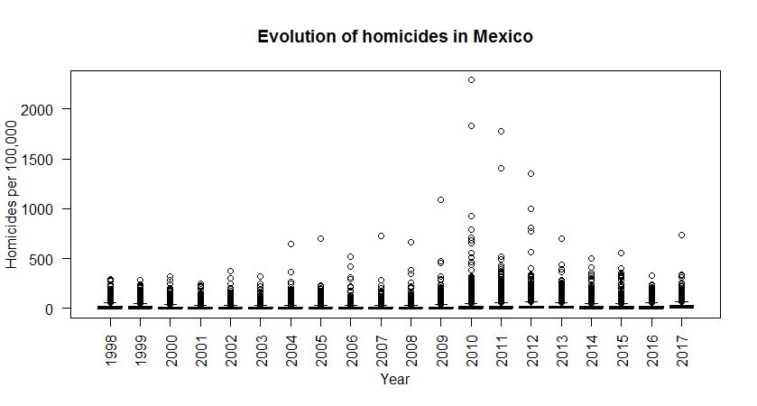

The proportion of beneficiaries, which is the main independent variable shows a more stable behaviour, with an increase after the consolidation of the Programme, but after that similar levels across time. However, what will be useful for the analysis is the spread in the proportion among different municipalities which is evidenced by the large distribution of the minimum and maximum values throughout the municipalities, as shown in Figure 5.

**Figure 5. Evolution of proportion of beneficiaries**

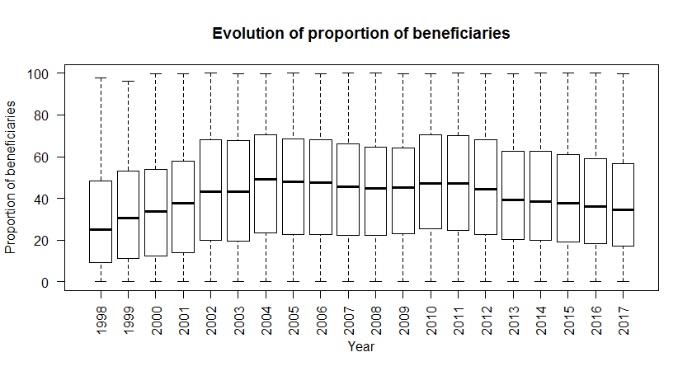

The aforementioned effects are confirmed by comparing the boxplots with the distribution of the proportion of homicides and beneficiaries and the histograms with the frequencies of observations. In this regard, figure 6 shows what we already spotted through the analysis of the quartiles, has a strongly right-skewed distribution, while the proportion of beneficiaries is more uniformly distributed but slightly right-skewed as well. As we will see in section 4.2, this makes necessary to carry some transformations to the dependent variable in order to be able to apply a linear model or use, instead, a different type of model, considering a Poisson distribution, for instance.

**Figure 6. Distribution of main variables**

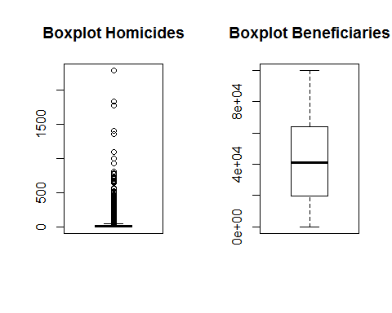

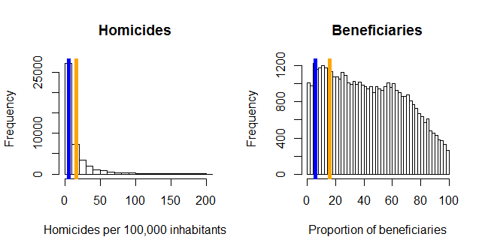

The inspection of the linear relationship between the dependent and main independent variable does not show a clear pattern due to the strong concentration of cases around the lowest values of the homicide distribution. A slight negative relationship can be spotted in the overall picture of figure 7, but only caused by the presence of extreme cases of homicide rates already explained. The correlation using the homicides per 100,000 inhabitants directly and the proportion of beneficiaries is of -0.008 and increases slightly but no to detect a considerable effect when I included the logarithmic measure of the homicides -0.132.

**Figure 7. Homicides per proportion of beneficiaries**

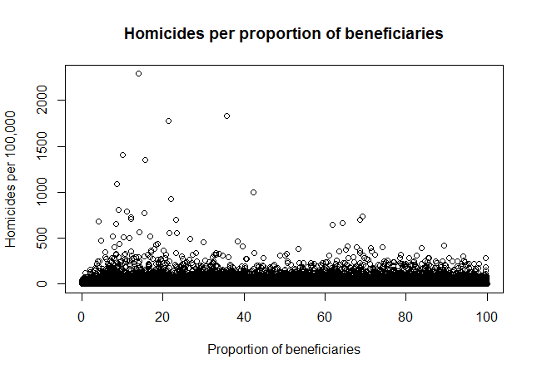

In order to conduct the fixed-effects model, it is important to have heterogeneity in the variables across time and across the units of measurement or; otherwise, their impact would be considered as fixed and therefore discarded from the estimation. This effect is caused by the within transformation, which means that demeaned data is generated by the model by subtracting the mean values per individual from the observations of each panel in both, the independent and dependent variables (Wooldridge, 2013).

In this regard, figures 8 and 9 present the heterogeneity of cases across the distribution of municipalities and years regarding the homicides rates. The x labels were omitted intentionally from figure 8 to improve the presentation of the graph. Regarding the dispersion by municipalities, we confirm the strong presence of cases around the 0 line but different levels of homicides within and across municipalities. Also, regarding the variation in time, we can confirm the initial reduction, followed by a sudden increase in the homicides registered after 2007, a new reduction but constant increase at the end of the distribution. Also, we can observe that during the years with the highest levels of violence, the variability across observations is the highest which suggest particular effects by municipality that are worth studying through a fixed-effects model.

**Figure 8. Heterogeneity of proportion of homicides by municipality**

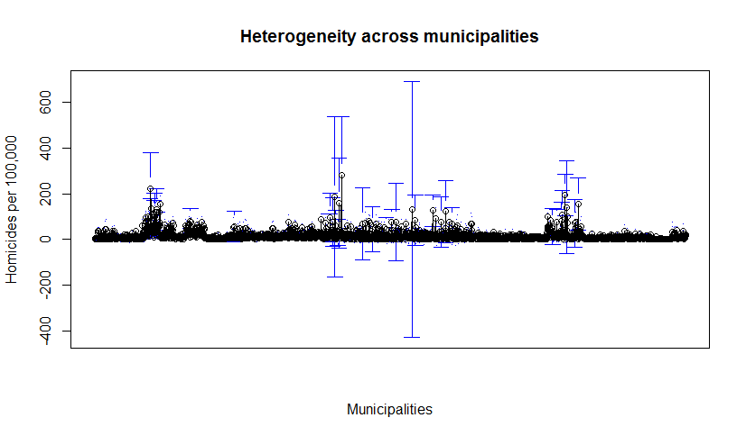

Municipalities

**Figure 9. Heterogeneity of proportion of homicides by year**

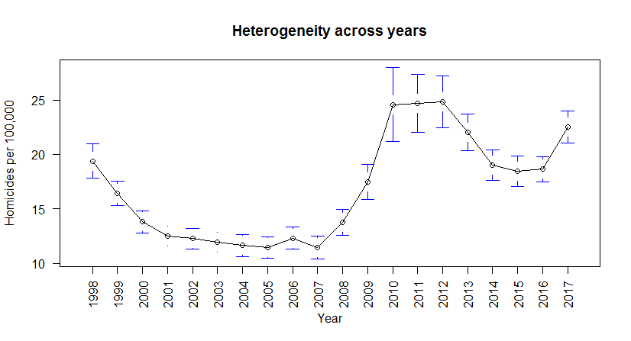

## Assessment of normality in the dependent variable

As we already stated through the analysis of the distribution of the observations of the rate of homicides by 100,000 inhabitants, the shape of the distribution does not allow to conduct an Ordinary Least Squares analysis, since the Gauss-Markov assumptions are not clearly met. Just with the visual inspection, we have a general idea that linearity is not met., and at least it is unclear whether the zero-conditional mean, homoscedasticity and normality in the distribution of errors are met. Figure 10 shows the diagnostic plots to assess the plausibility of using a linear model to study the effects of the number of beneficiaries on the homicide rate. The comparison of the residuals versus fitted values shows various outliers as well as a pattern of increase of the value of the residuals when Ŷ increases. Another concern is the bandwidth in which the graph is plotted, creating questions about heteroscedastic residual distributions. Moreover, the normal probability plot shows a clear pattern of non-normally distributed errors. The Scale-Location also presents serious patterns at the right side of the fitted values creating concerns of deviations from homoscedasticity. Finally, the last plot, which reflects Cook’s distance, shows the presence of various leverage points or observations with strong influence in our regression line.

**Figure 10. Diagnostic statistics of a simple linear model**

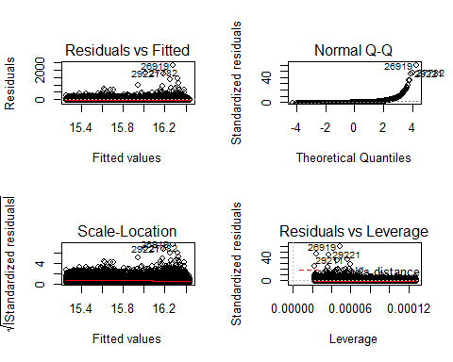

To solve the problem, I conducted a natural logarithmic transformation on the homicides rate, which is a commonly used transformation to reduce right skewness with a stronger effect in the distribution shape than alternative approaches such as cube roots or squared roots (Pek et al., 2017 and Cox, 2005). However, since there are different values reported in 0, I included the logarithmic transformation of ln(x+1) in order to avoid having undefined cases. After conducting the transformation in the dependent variable, I conducted the diagnostic tests again with the results that are shown in figure 11. As noted in the new set of graphs, the residuals versus fitted, Scale-Location and residuals versus leverage now present a more random allocation and within a considerably small bandwidth. Furthermore, for the most part of the normal Q-Q plot, the values are located near to a 45-degree line that would show a perfect normally distributed errors.

**Figure 11. Diagnostic statistics of a linear model with ln**

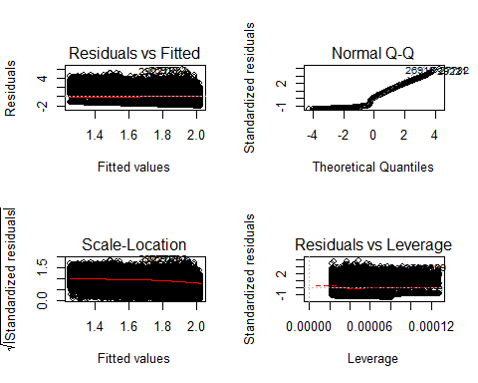

## Summary of results

With the transformation in the dependent variable, I proceeded to conduct different versions of fixed-effects models to assess the impact of the variation in the proportion of beneficiaries across municipalities in homicide rates. To do so, I used the plm R package, which was specifically developed to conduct analysis of panel data econometrics and cope with unobserved heterogeneity (Croissant and Millo, 2008). Particularly, I used the within specification to conduct a one-way fixed-effects model. Table 2 summarises the results for seven different models conducted. All tables in this section report clustered robust standard errors, since fixed-effects models control part of the within-cluster correlation of errors but not all within variances and heteroscedasticity across municipalities (see Cameron and Miller, 2015). A note on the R squared estimators relevant to mention is that the R squared is based on the within transformation and, hence, is only interpreted as “the amount of time variation in the $y_{it}$ that is explained by the time variation in the explanatory variables” (Wooldridge, 2013, p. 487). Therefore, it is not adequate to assess goodness of fit but is included in the reports to guarantee transparency. Finally, the database, as well as the code in R are available to download at <https://github.com/MSc-EBSIPE/Thesis_Violence_Mexico>

The first model only included the proportion of beneficiaries as a predictor of the number of homicides in a given municipality. As noted in Table 2, there is no significant effect when using robust standard errors. This would mean that, overall, there is no difference in the number of homicides associated with the level of beneficiaries of the social programme. However, the second model, which includes the variable of military intervention to differentiate the years comprehending the war on drugs, suggest that a greater proportion of beneficiaries of PROSPERA have an effect on the reduction in homicides overall across the whole period, once we account for the increase by the military interventions. In this regard, every point increased in the proportion of beneficiaries, that is, an increase in 1% of the total number of households of the municipality being part of the PROSPERA, would reduce the homicide rates per 100,000 in 0.52 points. Although the table only shows three digits for simplicity, the complete coefficient is -0.00522717, which, by applying the back-transformation ${(e}^{-β_{1}}-1)*100$, results in a reduction of 0.52. This would mean that a municipality with the average value of homicides per 100,000 inhabitants (15.9) would need to increase 30.5% its proportion of beneficiaries to reduce their homicides to 0. If we consider the mean value of the proportion of beneficiaries (42.7%), a municipality in the average would have to increase their beneficiaries in order to cover 73.2% of its households to be able to eradicate homicides from its territory. However, there is also an effect in the opposite direction and with a stronger magnitude caused by the military operations to fight the drug trafficking organisations.

Another relevant finding is the presence of differentiated effects by the introduction of the joint operations and the direct fight against criminal organisations, which was suggested by model 2, but is confirmed by the fact that the interaction term between the proportion of beneficiaries and military interventions is significant at the 95% in all the models in which it was included (3 to 7). Model 3 is the one described in section 3.2 as the essential formulation to address the research question of this thesis since it is the basic form in which we can assess a differentiated impact of the proportion of beneficiaries across time. The results of this model show that both variables and their interaction result significant at least at the 95% level, even when introducing robust standard errors, which made the proportion of beneficiaries to reduce significance from a 99% level to a 95% but remained significant.

The rest of the models (3-7) include different control variables to assess for other socioeconomic effects or public services provision that could have an effect on the number of homicides. The need for including different specifications of these models comes from the fact that the inclusion of these variables reduces in some cases considerably the number of observations in which the analysis is conducted. For instance, the complete model that includes all main and control variables, (7) looses 41.3% of observations. Some of the points to highlight are that the proportion of beneficiaries is no longer significant, and the measures of medical units, births and infant death become significant. The direction of the effects suggests that places with good health coverage in terms of infrastructure (it could be because they have small populations or a strong presence of medical units) but without adequate attention of the population, which derives in more infant death, tend to have more homicides. Another relevant feature is that the military intervention and the interaction term between military intervention and the proportion of beneficiaries remain significant throughout the different models. Since the military intervention variable is a time dummy, what these results show is that beneficiaries reduced homicide before the military interventions started as I will show in detail with the further analysis presented below.

| **Table 2. Results** | | | | | | | |
| --- | --- | --- | --- | --- | --- | --- | --- |
|  | | | | | | | |
|  | Dependent variable: ln(Homicides per 100,000 inhabitants) | | | | | | |
|  |  | | | | | | |
|  |  | | | | | | |
|  | Beneficiaries | Military | Interaction | Health | Economic | Education | All |
|  | (1) | (2) | (3) | (4) | (5) | (6) | (7) |
|  | | | | | | | |
| Proportion of beneficiaries | -0.001 | -0.005*** | -0.002** | -0.001 | -0.001 | 0.0001 | 0.0001 |
| (0.001) | (0.001) | (0.001) | (0.001) | (0.001) | (0.001) | (0.001) |
|  |  |  |  |  |  |  |  |
| Military intervention |  | 0.348*** | 0.755*** | 0.710*** | 0.790*** | 0.717*** | 0.735*** |
|  | (0.016) | (0.029) | (0.032) | (0.034) | (0.032) | (0.040) |
|  |  |  |  |  |  |  |  |
| Health Workers |  |  |  | 0.0002 |  |  | 0.0001 |
|  |  |  |  | (0.0001) |  |  | (0.0001) |
|  |  |  |  |  |  |  |  |
| Medical Units |  |  |  | 0.001** |  |  | 0.002*** |
|  |  |  |  | (0.001) |  |  | (0.001) |
|  |  |  |  |  |  |  |  |
| Vehicles |  |  |  |  | 0.00000* |  | 0.00000 |
|  |  |  |  |  | (0.00000) |  | (0.00000) |
|  |  |  |  |  |  |  |  |
| Births |  |  |  |  | -0.0001*** |  | -0.0001*** |
|  |  |  |  |  | (0.00002) |  | (0.00002) |
|  |  |  |  |  |  |  |  |
| Infant Death |  |  |  |  | 0.004*** |  | 0.005*** |
|  |  |  |  |  | (0.001) |  | (0.001) |
|  |  |  |  |  |  |  |  |
| School Retention |  |  |  |  |  | 0.0004 | 0.00003 |
|  |  |  |  |  |  | (0.001) | (0.001) |
|  |  |  |  |  |  |  |  |
| School Approval |  |  |  |  |  | -0.0003 | 0.0004 |
|  |  |  |  |  |  | (0.001) | (0.001) |
|  |  |  |  |  |  |  |  |
| Interaction effect between beneficiaries and military intervention |  |  | -0.009*** | -0.009*** | -0.009*** | -0.009*** | -0.009*** |
|  |  | (0.001) | (0.001) | (0.001) | (0.001) | (0.001) |
| Observations | 44,156 | 44,156 | 44,156 | 40,623 | 34,944 | 37,866 | 30,004 |
| R2 | 0.0001 | 0.019 | 0.029 | 0.025 | 0.040 | 0.027 | 0.034 |
| Adjusted R2 | -0.057 | -0.037 | -0.027 | -0.036 | -0.028 | -0.038 | -0.045 |
| F Statistic | 4.294** (df = 1; 41771) | 401.314*** (df = 2; 41770) | 409.240*** (df = 3; 41769) | 197.791*** (df = 5; 38235) | 225.932*** (df = 6; 32652) | 200.639*** (df = 5; 35483) | 98.892*** (df = 10; 27712) |
| *Note:* | *p**p***p<0.01 | | | | | | |

As noted in Table 2, the interaction effect is significant in all the models included, which means that the level of homicides that vary depending on the proportion of beneficiaries depend on whether there was a military intervention or not. To show more intuitively this differentiated effect, Table 3 presents the results of the same models, but instead of reporting the interaction term, I included the military intervention as a parameter to subset the data. All the models that include an (M) comprehend the years with military operations to fight drug cartels (2007-2017) while (nM) represents the years previous to the beginning of the joint operations.

As already shown by the results of the interaction term, Table 3 confirms that there are considerable differences between the years before and after the war on drugs started. The first finding, which is very relevant for our research question is that the proportion of beneficiaries used to reflect a protective effect regarding homicides before 2007, where an increase in one percentage point in the household coverage by PROSPERA reflected a reduction in 0.93 homicides per 100,000 inhabitants. However, the effect is no longer significant after the beginning of the war on drugs, and we can find, instead, an increase of the homicide rate in municipalities with higher incomes and better provision of services, which is reflected by the positive relation between homicides and the number of registered vehicles and the proportion of health workers by 100,000 inhabitants. The findings are even more relevant because those same variables had a different sign in their coefficients before the military interventions started and significant effects in the case of vehicles regarding the reduction in homicides. Finally, it is important to point out that the level of income and public service provision is not necessarily related with the size of the municipality in demographic terms, since the number of births presents a negative relationship with homicides after 2007, although it is only significant at 90% confidence.

|  |  |  |  |  |  |  |  |  |  |  |
| --- | --- | --- | --- | --- | --- | --- | --- | --- | --- | --- |
| **Table 3. Results comparing years with and without military intervention** | | | | | | | | | | |
|  | | | | | | | | | | |
|  | Dependent variable: ln(Homicides per 100,000 inhabitants) | | | | | | | | | |
|  |  | | | | | | | | | |
|  |  | | | | | | | | | |
|  | Beneficiaries(M) | Beneficiaries(nM) | Health(M) | Health(nM) | Economic(M) | Economic(nM) | Education(M) | Education(nM) | All(M) | All(nM) |
|  | (1) | (2) | (3) | (4) | (5) | (6) | (7) | (8) | (9) | (10) |
|  | | | | | | | | | | |
| Proportion of beneficiaries | -0.002 | -0.009*** | 0.001 | -0.008*** | -0.002 | -0.009*** | 0.002 | -0.009*** | 0.002 | -0.009*** |
| (0.001) | (0.001) | (0.002) | (0.001) | (0.002) | (0.001) | (0.002) | (0.001) | (0.002) | (0.001) |
|  |  |  |  |  |  |  |  |  |  |  |
| Health Workers |  |  | 0.001*** | -0.0003 |  |  |  |  | 0.001*** | -0.0002 |
|  |  |  | (0.0001) | (0.0003) |  |  |  |  | (0.0002) | (0.0003) |
|  |  |  |  |  |  |  |  |  |  |  |
| Medical Units |  |  | 0.0004 | 0.0005 |  |  |  |  | 0.001 | 0.001 |
|  |  |  | (0.001) | (0.001) |  |  |  |  | (0.001) | (0.001) |
|  |  |  |  |  |  |  |  |  |  |  |
| Vehicles |  |  |  |  | 0.00000*** | -0.00000*** |  |  | 0.00000*** | -0.00000*** |
|  |  |  |  |  | (0.00000) | (0.00000) |  |  | (0.00000) | (0.00000) |
|  |  |  |  |  |  |  |  |  |  |  |
| Births |  |  |  |  | -0.0001** | 0.00001 |  |  | -0.00004* | 0.00001 |
|  |  |  |  |  | (0.00003) | (0.00002) |  |  | (0.00003) | (0.00002) |
|  |  |  |  |  |  |  |  |  |  |  |
| Infant Death |  |  |  |  | 0.0004 | 0.002*** |  |  | 0.00002 | 0.002*** |
|  |  |  |  |  | (0.001) | (0.001) |  |  | (0.001) | (0.001) |
|  |  |  |  |  |  |  |  |  |  |  |
| School Retention |  |  |  |  |  |  | 0.0001 | 0.001 | 0.00001 | -0.0001 |
|  |  |  |  |  |  | (0.001) | (0.001) | (0.001) | (0.001) |
|  |  |  |  |  |  |  |  |  |  |
| School Approval |  |  |  |  |  |  | 0.002* | -0.001 | 0.001 | 0.0005 |
|  |  |  |  |  |  | (0.001) | (0.001) | (0.001) | (0.001) |
| Observations | 25,149 | 19,007 | 22,719 | 17,904 | 21,966 | 12,978 | 21,288 | 16,578 | 18,149 | 11,855 |
| R2 | 0.0001 | 0.009 | 0.001 | 0.007 | 0.002 | 0.009 | 0.001 | 0.007 | 0.002 | 0.008 |
| Adjusted R2 | -0.104 | -0.132 | -0.116 | -0.141 | -0.114 | -0.144 | -0.124 | -0.158 | -0.141 | -0.158 |
| F Statistic | 1.583 (df = 1; 22781) | 142.989*** (df = 1; 16641) | 4.439*** (df = 3; 20352) | 35.483*** (df = 3; 15581) | 9.335*** (df = 4; 19686) | 25.647*** (df = 4; 11240) | 3.650** (df = 3; 18922) | 31.767*** (df = 3; 14224) | 4.766*** (df = 8; 15871) | 9.811*** (df = 8; 10158) |
|  |  |  |  |  |  |  |  |  |  |  |
| Note: | *p**p***p<0.01 | | | | | | | | | |

If we look more detailed into the different periods of shifts in the homicide trends in Mexico, it is possible to have a more specific account of the effect of the beneficiaries in homicides. To do this, I divided the data into four periods: i) before the war on drugs (1998-2006); ii) the initial period of increase in homicides right after the beginning of the joint operations (2007-2011); iii) a short period of decrease in homicides (2012-2014) and, iv) a new increase that continues until the date of presentation of this thesis (2015-2017). By analysing the simplest version of the models, we can observe the significant reduction in homicides by the proportion of beneficiaries before 2007. However, in the next period, the variable remains significant but with a positive sign, which means that the number of homicides increased right after the beginning of the military operations in places that have a bigger proportion of beneficiaries. Then, during the short period of decrease in homicides, the proportion of beneficiaries apparently did not take any part on such effect. The most interesting point to highlight is the last period. Even when the homicides rates have increased considerably, there appears to be a protective effect in those municipalities where there is a higher proportion of beneficiaries of PROSPERA and with twice the size of the effect than the period before the war on drugs started.

| **Table 4. Results comparing different periods** | | | | |
| --- | --- | --- | --- | --- |
|  | | | | |
|  | Dependent variable: : ln(Homicides per 100,000 inhabitants) | | | |
|  |  | | | |
|  |  | | | |
|  | 1998-2006 | 2007-2011 | 2012-2014 | 2015-2017 |
|  | (1) | (2) | (3) | (4) |
|  | | | | |
| Proportion of beneficiaries | -0.009*** | 0.017*** | 0.002 | -0.018*** |
| (0.001) | (0.003) | (0.005) | (0.006) |
| Observations | 19,007 | 11,527 | 6,764 | 6,858 |
| R2 | 0.009 | 0.005 | 0.0001 | 0.002 |
| Adjusted R2 | -0.132 | -0.251 | -0.518 | -0.506 |
| F Statistic | 142.989*** (df = 1; 16641) | 44.998*** (df = 1; 9170) | 0.252 (df = 1; 4455) | 10.335*** (df = 1; 4543) |
|  | | | | |
| Note: | *p**p***p<0.01 | | | |

A drawback for this reduction after 2015 in municipalities with a high proportion of beneficiaries comes when we include all the variables into our model. The proportion of beneficiaries in the last period remains to have a big coefficient and a negative relationship with homicides. Yet, its standard error increases and it stops to have a significant effect on the reduction of homicides. Moreover, none of the variables included appears to be significant in the homicides increase or reduction by municipality. Nevertheless, we need to consider that the number of observations drops considerably from 6,858 in the model that only includes the proportion of beneficiaries to 2,989 since some of the variables do not have register for 2017 at the moment of writing this thesis.

| **Table 5. Results comparing different periods, all variables** | | | | |
| --- | --- | --- | --- | --- |
|  | | | | |
|  | Dependent variable: : ln(Homicides per 100,000 inhabitants) | | | |
|  |  | | | |
|  |  | | | |
|  | 1998-2006 | 2007-2011 | 2012-2014 | 2015-2017 |
|  | (1) | (2) | (3) | (4) |
|  | | | | |
| Proportion of beneficiaries | -0.009*** | 0.014*** | -0.001 | -0.027 |
|  | (0.001) | (0.003) | (0.008) | (0.021) |
|  |  |  |  |  |
| Health Workers | -0.0002 | 0.0004 | -0.0001 | -0.001 |
|  | (0.0003) | (0.0003) | (0.001) | (0.001) |
|  |  |  |  |  |
| Medical Units | 0.001 | 0.001 | 0.008 | -0.004 |
|  | (0.001) | (0.002) | (0.008) | (0.003) |
|  |  |  |  |  |
| School Approval | 0.0005 | -0.0001 | 0.002 | 0.003 |
|  | (0.001) | (0.002) | (0.003) | (0.005) |
|  |  |  |  |  |
| Births | 0.00001 | -0.00004 | 0.00000 | 0.00000 |
|  | (0.00002) | (0.00003) | (0.0001) | (0.0002) |
|  |  |  |  |  |
| Infant Death | 0.002*** | -0.001 | -0.007*** | -0.002 |
|  | (0.001) | (0.002) | (0.003) | (0.005) |
|  |  |  |  |  |
| School Retention | -0.0001 | 0.004* | -0.002 | 0.001 |
|  | (0.001) | (0.002) | (0.003) | (0.002) |
|  |  |  |  |  |
| Vehicles | -0.00000*** | 0.00001*** | -0.00000 | 0.00000 |
|  | (0.00000) | (0.00000) | (0.00000) | (0.00000) |
| Observations | 11,855 | 10,817 | 4,343 | 2,989 |
| R2 | 0.008 | 0.008 | 0.002 | 0.011 |
| Adjusted R2 | -0.158 | -0.255 | -1.036 | -2.779 |
| F Statistic | 9.811*** (df = 8; 10158) | 8.543*** (df = 8; 8548) | 0.538 (df = 8; 2128) | 1.084 (df = 8; 782) |
|  | | | | |
| Note: | *p**p***p<0.01 | | | |

## Inclusion of variable of cartel competition

The same models were replicated for a subset of the data in order to account for completion among organised crime organisations in Mexico, which is one of the other alternative explanations for the violence in Mexico. The data for this analysis was obtained from the study conducted by Coscia and Ríos (2012) to systematise a methodology to account for cartel competition and presence. The reason for including this data as a separate subheading is that, despite its relevance, it was collected until 2010 and the time constraints for this research did not allow to replicate the methodology for the following years. In this regard, results should be taken with caution due to the fact that there is a reduced sample of the data.

Table 6 shows the results for the model already explained in section 4.3 that includes the differentiation between the periods of military interventions or previous years but with the addition of the number of cartels that had presence in each municipality by year. One of the main findings that we observe by including this new variable of competition among cartels is that by including the cartels' presence, the number of beneficiaries is significant for all the models, with a positive effect on homicides after the war on drugs began and a negative effect during the previous years.

If we compare these results with those of Table 3, the inclusion of the new variable suggests, first, that the same protective effect against homicides occurred in municipalities with presence of more criminal organisations. Second, it makes clear that despite that in the original model there was no significant effect of the proportion of beneficiaries during the armed conflict, after 2007, the effect becomes significant and positive if we include the cartels variable. This means that within the municipalities with more presence of cartels, those with more proportion of beneficiaries of PROSPERA had higher homicide rates. Finally, it is important to highlight that after 2007, the presence of more cartels explains the increase in homicide rates, supporting the idea that conflict between criminal organisations is creating instability and increasing the rate of homicides in the municipalities affected.

|  |  |  |  |  |  |  |  |  |  |  |
| --- | --- | --- | --- | --- | --- | --- | --- | --- | --- | --- |
| **Table 6. Results comparing years with and without military intervention including the presence of Cartels** | | | | | | | | | | |
|  | | | | | | | | | | |
|  | Dependent variable: | | | | | | | | | |
|  |  | | | | | | | | | |
|  |  | | | | | | | | | |
|  | Beneficiaries(M) | Beneficiaries(nM) | Health(M) | Health(nM) | Economic(M) | Economic(nM) | Education(M) | Education(nM) | All(M) | All(nM) |
|  | (1) | (2) | (3) | (4) | (5) | (6) | (7) | (8) | (9) | (10) |
|  | | | | | | | | | | |
| Proportion of beneficiaries | 0.014*** | -0.009*** | 0.013*** | -0.008*** | 0.013*** | -0.010*** | 0.014*** | -0.009*** | 0.012*** | -0.009*** |
| (0.003) | (0.001) | (0.003) | (0.001) | (0.004) | (0.001) | (0.003) | (0.001) | (0.004) | (0.001) |
|  |  |  |  |  |  |  |  |  |  |  |
| Health Workers |  |  | 0.0003 | -0.0003 |  |  |  |  | 0.0005 | -0.0002 |
|  |  | (0.0004) | (0.0003) |  |  |  |  | (0.0004) | (0.0003) |
|  |  |  |  |  |  |  |  |  |  |  |
| Medical Units |  |  | 0.003 | 0.0005 |  |  |  |  | 0.002 | 0.001 |
|  |  | (0.003) | (0.001) |  |  |  |  | (0.003) | (0.001) |
|  |  |  |  |  |  |  |  |  |  |  |
| Vehicles |  |  |  |  | 0.00000*** | -0.00000*** |  |  | 0.00000*** | -0.00000*** |
|  |  |  |  | (0.00000) | (0.00000) |  |  | (0.00000) | (0.00000) |
|  |  |  |  |  |  |  |  |  |  |  |
| Births |  |  |  |  | -0.0001*** | 0.00001 |  |  | -0.0001*** | 0.00001 |
|  |  |  |  |  | (0.00003) | (0.00002) |  |  | (0.00003) | (0.00002) |
|  |  |  |  |  |  |  |  |  |  |  |
| Infant Death |  |  |  |  | 0.001 | 0.002*** |  |  | 0.001 | 0.002** |
|  |  |  |  |  | (0.002) | (0.001) |  |  | (0.002) | (0.001) |
|  |  |  |  |  |  |  |  |  |  |  |
| School Retention |  |  |  |  |  |  | 0.002 | 0.001 | 0.003 | -0.0001 |
|  |  |  |  |  |  | (0.002) | (0.001) | (0.002) | (0.001) |
|  |  |  |  |  |  |  |  |  |  |  |
| School Approval |  |  |  |  |  |  | -0.00005 | -0.001 | -0.0003 | 0.001 |
|  |  |  |  |  |  | (0.002) | (0.001) | (0.002) | (0.001) |
|  |  |  |  |  |  |  |  |  |  |  |
| Cartels | 0.263*** | 0.027 | 0.262*** | 0.051** | 0.260*** | 0.050* | 0.252*** | 0.027 | 0.248*** | 0.070*** |
|  | (0.022) | (0.025) | (0.022) | (0.024) | (0.022) | (0.027) | (0.022) | (0.026) | (0.023) | (0.026) |
| Observations | 9,251 | 19,007 | 9,121 | 17,904 | 8,854 | 12,978 | 9,137 | 16,578 | 8,638 | 11,855 |
| R2 | 0.017 | 0.009 | 0.017 | 0.007 | 0.018 | 0.009 | 0.017 | 0.007 | 0.018 | 0.008 |
| Adjusted R2 | -0.319 | -0.132 | -0.325 | -0.141 | -0.319 | -0.144 | -0.324 | -0.158 | -0.331 | -0.158 |
| F Statistic | 60.611*** (df = 2; 6894) | 71.833*** (df = 2; 16640) | 29.667*** (df = 4; 6762) | 27.181*** (df = 4; 15580) | 24.370*** (df = 5; 6589) | 21.089*** (df = 5; 11239) | 29.579*** (df = 4; 6780) | 24.013*** (df = 4; 14223) | 13.005*** (df = 9; 6371) | 9.275*** (df = 9; 10157) |
|  | | | | | | | | | | |
| Note: | *p**p***p<0.01 | | | | | | | | | |

# Robustness tests

In this section, I report a series of robustness checks that I conducted to explore the variations in the results when using different data. The analysis should be robust to different choices if the effects obtained by the different models are derived consistently from the dataset constructed. In this regard, I replicated the models from tables 2 and 3, that is, the initial models and the specifications for the pre and post-military interventions but using the imputation method of last observation carried forward. The results are presented in the appendix, as long with the rest of the assessments conducted.

The results show that, in general, the same conclusions hold for the initial models that repeat the same observation of population, with slight variations in some of the coefficients. However, the proportion of beneficiaries in the interaction model reduces its coefficient from -0.002 to -0.001, making that with robust standard errors, the results are no longer significant. Nonetheless, the results remain significant at 90% when reporting the normal standard errors, but this means that the results from the simplest model of interaction should be taken with caution in terms of the overall effect of the proportion of beneficiaries for the complete period 1998-2017.

Similar findings were obtained by dividing the models using the military intervention variable as a parameter. Again, there are differences in some of the coefficients, but the significance of the main variables and, hence, the conclusions derived from the models hold for all models, with the exception of the proportion of beneficiaries for the beneficiaries (initial) and economic models with military interventions. While by using the linear regression imputation of households and population the proportion of beneficiaries did not result significant, when using the repeated value we observe that there is a significant negative effect of the proportion of beneficiaries in homicides, even for the 99% of confidence for the period after military interventions started. However, when incorporating the whole set of variables, the variables that were significant in table 3 remain significant when using the imputation that carries forward the last observation and with the same sign. The proportion of beneficiaries reports a negative effect instead of positive, but it remains as non-significant.

# Discussion

The results from the different variations of the fixed-effects models show that, consistent with previous studies, overall social expenditures seem to have an effect in reducing homicides in Mexico. However, the beginning of the joint operations by the State to confront drug trafficking organisations disrupted this protective factor created by the CCT. The immediate effect was that, in general, the proportion of beneficiaries lost its significance in explaining the levels of murders in the Mexican municipalities and, in those places with more presence of cartels, the effect completely reversed. A possible explanation for this effect is that once the military created disruption within cartels through the war on drugs, the conflicts between drug trafficking organisations were triggered and vulnerable populations suffered more from these conflicts in strategic points for market control but with a vulnerable population that could replace the casualties of the confrontations.

This does not mean, however, that since there is no immediate association between homicides and social expenditures in the presence of violent criminal organisations, a social protection and prevention scheme should be abandoned. What it implies in terms of policy is that social protection might not be enough to counter the effect of disruption created by the armed conflict, but that it is effective in reducing homicides under the context of relative normality by increasing the costs of joining a criminal organisation as shown by the first set of models. In this regard, it is very relevant to maintain a strategy of primary prevention by offering a safety net or minimum ground to reduce the incentives of joining criminal organisations. Especially, considering that from 2015 onwards it appeared that the proportion of beneficiaries of PROSPERA was regaining influence in reducing homicides, despite an overall increase in the homicide rates. However, this strategy would not solve the problem in the long run if criminal organisations are still operating, especially through predatory strategies to expand their territories caused by the beheading of the original structures.

Also, it is especially important to continue supporting a scheme of social protection based on promoting human development. The current policy of dismantling the conditionality of PROSPERA to change it for a scholarship scheme requires a better assessment of the possible effects. The results of this thesis, for instance, suggest that education variables were not significant in any of the models to explain a reduction in homicides, neither before the joint operations to fight organised crime, nor after 2007. Hence, abandoning the holistic approach created by PROSPERA to increase social support might lose its effect with the new configuration of the programme. Despite I acknowledge the existing debate regarding the effectiveness of conditional versus unconditional transfers (Baird, 2013), shifting the programme that is offering considerably good results in diverse variables would require at least a strong justification based on evidence and a clear diagnosis of implementing an alternative approach, which has not yet been presented by the Mexican Government.

Another point to highlight is that besides the disruptive effect created by military interventions, it is possible that the incentives to join the organised crime are not only related with having a safety net to cope with poverty or overall inequality, generating problems for the causal theory behind the effectiveness of social protection. According to McMillan (2013), being a member of a gang in a local context in Mexico did not predict further membership in organised crime, since the incentives to join one or another type of criminal group varied considerably. Also, available ethnographic research points to the fact that the main driver for joining a drug cartel is not poverty generating social disorganisation or lack of social support to face unexpected adverse circumstances, as the main theories mention, but inequality in lifestyles and consumption habits, which poses a serious threat to the success of the prevention strategies. For instance, right before the escalation of drug-related violence in Mexico, McDonald (2005) analysed the influence of narcoeconomy in rural Mexico. His main finding was that there was an adoption or even routinisation of new forms of consumption in the rural economies due to the introduction of illegal money. However, since the majority of the community could not actually take part in them, the underpinning inequalities “made the narco-life appear as a potentially desirable strategy for economic success”. (McDonald, 2005, p. 120).

In this regard, if the desire of increasing income to the luxurious levels that are normally portrayed in media and by the interactions of the drug capos and lieutenants with the community have a relevant influence in the decision of joining a cartel, they pose significant threats to the effectiveness of preventive strategies. To address the issue, such strategies should consider reinforcing the education policy and an information campaign to socialise the fact that such lifestyles are not a reality for the majority of the members of the cartels (Pérez-Correa and Azaola, 2012).

Finally, the results of the analysis conducted and different variations of inclusion of control variables confirm what others authors (Escalante, 2011, Merino, 2011 or Espinosa and Rubin, 2015) have already proven widely, that the start of the joint operations increased the number of homicides throughout the country significantly. Also, by including the data on the cartel presence and interaction, the thesis stating that the conflict among cartels is causing more homicides stated by authors such as Coscia and Ríos (2012) or Calderón et al. (2015), is also confirmed.

# Limitations

One limitation of this study relates to the fact that, despite the fixed-effects model offers a robust estimation that considers unobserved effects that might be affecting the municipalities, the lack of an experimental or quasi-experimental design does not allow to assess causation from the results. An alternative approach was to conduct a quasi-experimental design; however, the fact that the proportion of beneficiaries was not a clear intervention did not offer the conditions to conduct a sound natural experiment to address the research question.

Another important limitation of the analysis is the fact that the variable of military interventions was considered only as a subset of the variation in time (pre and post-2007). Being such an important predictor of the homicide rates for a context of direct confrontation between drug trafficking organisations and the State, it would be important to have more detail throughout the period of study of the particular operations conducted in each municipality. An alternative was to conduct an analysis based on official press releases by the Government as well as an analysis of local media, as Escalante (2011) did. However, I already mentioned elsewhere that such an approach would require a longer analysis and possibly not comparable data due to the changes in media coverage after the agreement signed by the main broadcasters in 2011.

I also acknowledge that the data for cartel interactions is available only for some years, which according to some previous evidence that used synthetic controls, might have a considerable impact on the homicides and wipe out the effects of the beneficiaries (Calderón et al., 2015). It would be very enlightening to conduct a complete analysis. However, the available data allowed to strengthen the results by controlling the analysis by cartel presence, since someone might argue that the reduction in homicides might have been a consequence of lack of interest by drug trafficking organisations in controlling the market of municipalities experiencing harsh economic conditions. Such an explanation was discarded by including the variable of cartel presence and help to assess the effect of the proportion of beneficiaries for the municipalities that struggle with territorial disputes within organisations.

Another drawback is that the data I had on homicides is not restricted to drug violence. For policy implications, this fact can be helpful, since the conclusions can apply to any type of homicides, which might be in the interests of any Government to reduce. However, since the research sought to address particularly the shifts in the effects of social protection under organised crime contexts, it would be useful to disentangle the effect of the intervention. Another issue was the lack of information for some of the variables for certain years, which reduced the statistical power of some of the tests. For instance, the number of schools by municipality was excluded from all models due to its large number of NAs.

Finally, I acknowledge that despite the use of a fixed-effects model allows to account for unobserved time-invariant confounders, making the model more robust against the disparities among compositional characteristics of the municipalities, it comes at the expense of dynamic causal relationships between the outcome and treatment variables (Imai and Kim, 2019).

# Conclusion

This thesis analysed the effect of social expenditures in Mexico, measured by the proportion of beneficiaries of its main CCT strategy to fight poverty, in deterring homicides. After a series of fixed-effects models assessing different variations in the variables included, it was demonstrated that the reduction in homicides generated by a greater proportion of beneficiaries of PROSPERA, became non-significant with the war on drugs, after 2007. The effect was even reversed when controlling by the presence of drug cartels in the municipalities, suggesting that cartels targeted vulnerable populations possibly as ways to renew their lines, or as unfortunate casualties in their intentions to control strategic market points after the military interventions. However, a promising protective effect of the proportion of beneficiaries seemed to appear after 2015, even when the total number of homicides increased in the country.

The results contribute to informing public policy decisions that are being currently implemented in Mexico to address the increasing levels of violence, especially by warning on the changes that PROSPERA is experimenting to become a scholarship programme instead of a CCT. Also, the results speak to the bulk of literature that assesses the relationship between social expenditures and homicides, which consistently reported a negative association, but did not account for specific contexts like the presence of organised crime that creates different challenges to be addressed by the social policy. At the end of the day, social support through expenditures should not be abandoned and, instead, should be strengthened and complemented with long term strategies and effective addressing of the short term issues that the presence of organised crime generates.

# References

Allison Paul D. (2009). *Fixed effects regression models.* London: SAGE.

Angrist, Joshue D. & Pischke, Jörn Stephen. (2009). *Mostly Harmless Econometrics : An Empiricist's Companion.* New Jersey: Princeton University Press.

Associated Press. (2017, July, 5th). “Mexico gun battle between gangs leaves at least 14 dead”. Retrieved from: <https://www.telegraph.co.uk/news/2017/07/05/mexico-gun-battle-gangs-leaves-least-14-dead/>

Baird, Sarah, Ferrerira, Francisco H.G., Özler, Berk & Woolcock, Michael. (2013). “Relative Effectiveness of Conditional and Unconditional Cash Transfers for Schooling Outcomes in Developing Countries: A Systematic Review.” *Campbell Systematic Reviews.* 2013(8).

Beyliss, Marcelo. (2010, July 2nd). “Muertos de Tubutama eran originarios de Sonora, Sinaloa y Tamaulipas”. *W Radio.* Retrieved from <http://wradio.com.mx/radio/2010/07/02/judicial/1278109740_321857.html>

Brito, Steve, Corbacho, Ana & Osorio, René. (2014) “Remittances and the Impact on Crime in Mexico”. *IDB Working Paper Series, No. IDB-WP-514*. Inter-American Development Bank (IDB). Washington, DC.

Calderón, Gabriela, Robles, Gustavo, Díaz-Cayeros, Alberto & Magaloni, Beatriz. (2015). “The Beheading of Criminal Organizations and the Dynamics of Violence in Mexico”. *Journal of Conflict Resolutions*. V. 59(8): 1455-1485.

Camacho, Adriana & Mejía, Daniel. (2013). *Las externalidades de los programas de transferencias condicionadas sobre el crimen. El caso de Familias en Acción en Bogotá*. IDB working paper series 406, Inter-American Development Bank.

Cameron, A. Colin & Miller, Douglas L. (2015). “A Practitioner’s Guide to Cluster-Robust Inference”. *The Journal of Human Resources.* V. 50(2): 317-372.

Cejudo, Guillermo M. (2019, February 5). *La política social de AMLO (III)* [Blog post]. Retrieved from <https://www.animalpolitico.com/blogueros-intuiciones-evidencia/2019/02/05/la-politica-social-de-amlo-iii/>

Chamlin, M.B., Cochran, J.K. & Lowenkamp, C.T. (2002). “A longitudinal analysis of the welfare-homicide relationship: testing two (nonreductionist) macro-level theories”. *Homicide Studies*. V. 6: 39–60.

Chávez Villegas, Cirenia. (2018). “Penalization and multidimensional poverty: improving our understanding of poverty amongst offenders in Ciudad Juarez, Mexico”. *Crime Law Soc Change*. V. 70:621–645.

Chioda, Laura, De Mello, João M. P. & Soares, Rodrigo R. (2013) “Spillovers from Conditional Cash Transfer Programs: Bolsa Família and Crime in Urban Brazil”. *Economics of Education Review*. V. 54: 306–320.

Coscia, Michele & Ríos, Viridiana (2012). “Knowing where and how criminal organizations operate using web content”. *Proceedings of the 21st ACM international conference on information and knowledge management*. Pp. 1412-1421.

Cox, Nicholas J. (2005) *Transformations: an introduction.* Retrieved from <http://fmwww.bc.edu/repec/bocode/t/transint.html>

Croissant, Yves & Millo, Giovanni. (2008). “Panel Data Econometrics in R: The plm Package”. *Journal of Statistical Software.* V. 27(2).

Currie, Elliot. (1997). “Market, crime and community: toward a mid-range theory of post-industrial violence”. *Theoretical Criminology.* V. 1(2): 147-172.

Dávila Lárraga, Laura G. (2016). *How Does PROSPERA Work? Best Practices in the Implementation of Conditional Cash Transfer Programs in Latin America and the Caribbean*. Technical Note Nº IDB-TN-971. Inter-American Development Bank.

Enamorado T, López-Calva LF, Rodríguez-Castelán C & Winkler H. (2016). “Income inequality and violent crime: Evidence from Mexico’s drug war”. *Journal of Development Economics*. V. 120: 128-143.

Escalante, Fernando. (2011). “Homicidios 2008–2009: La Muerte Tiene Permiso”. *Revista Nexos*. Retrieved from http://www.nexos.com.mx/?p=14089.

Espinosa, Valeria & Rubin, Donald B. (2015). Did the Military Interventions in the Mexican Drug War Increase Violence? *The American Statistician.* V. 69(1): 17-27.

Fajnzylber, Pablo, Lederman, Daniel & Loayza, Norman (2002). “What causes violent crime?”. *European Economic Review.* V. 46: 1323:1357

Fiszbein, Ariel & Schady, Norbert. (2009). *Conditional Cash Transfers: Reducing Present and Future Poverty*. World Bank Publications: Washington D.C.

*Guidelines for the operation of the Programme PROSPERA*. (2019, February 28). Retrieved from <https://www.dof.gob.mx/nota_detalle.php?codigo=5551581&fecha=28/02/2019>

*Guidelines for the operation of the Programme Young People Building Future*. (2019, January 10). Retrieved from <https://dof.gob.mx/nota_detalle.php?codigo=5547857&fecha=10/01/2019>

HM Government. (2013). *Serious and Organised Crime Strategy*. Retrieved from: <https://www.gov.uk/government/uploads/system/uploads/attachment_data/file/248645/Serious_and_Organised_Crime_Strategy.pdf>

Imai, Kosuke. (2017). *Quantitative Social Science – An Introduction.* Princeton University Press: Princeton/Oxford.

Imai, Kosuke & Kim, I.S. (2019). “When Should We Use Unit Fixed Effects Regression Models for Causal Inference with Longitudinal Data?” *American Journal of Political Science*. V. 63(2): 467-490.

INEGI. (2019). *Deaths by homicides, 1990 to 2017* [Data set]. Retrieved from <https://www.inegi.org.mx/sistemas/olap/proyectos/bd/continuas/mortalidad/defuncioneshom.asp?s=est>

Institute for Economic and Peace (2018). *Índice de Datos sobre Homicidios*. Retrieved from <http://economicsandpeace.org/wp-content/uploads/2018/08/Indice-de-Datos-sobre-Homicidios-2018.pdf>

Lance, Justin Earl (2014). “Conditional Cash Transfers and the Effect on Recent Murder Rates in Brazil and Mexico”. *Latin American Politics and Society.* V. 56(1): 55-72.

Loureiro, André. (2012). “Can Conditional Cash Transfers Reduce Poverty and Crime? Evidence from Brazil”. Retrieved from <http://ssrn.com/abstract=2139541>

Lozano, José Carlos. (2016). “El Acuerdo para la Cobertura Informativa de la Violencia en México: Un intento fallido de autorregulación”. *Comunicación y Sociedad*. V. 26: 13-42.

McCall, Patricia L. & Brauer, Jonathan R. (2014). “Social welfare support and homicide: Longitudinal analyses of European countries from 1994 to 2010”. *Social Science Research*. V.48: 90–107.

McDonald, James H. (2005) “The Narcoeconomy and Small-town, Rural Mexico”, *Human Organization*, 64, 2.*National Plan for Peace and Security 2018-2024.* (2018). Retrieved from <https://lopezobrador.org.mx/wp-content/uploads/2018/11/Plan-Nacional-de-Paz-y-Seguridad_.pdf>

McMillan Smith, Worrall. (2013). *Mixing Methods in Mexico: Youth Gangs and Organized Crime in the “Structurally Maladjusted” areas of Monterrey* (Master’s Degree dissertation). Retrieved from <https://lup.lub.lu.se/student-papers/search/publication/3799344>

Meloni, Osvaldo. (2014). “Does poverty relief spending reduce crime? Evidence from Argentina”. *International Review of Law and Economics*. V. 39: 28-38.

Merino, José. (2011). “Los Operativos Conjuntos y la Tasa de Homicidios: Una Medición”. *Revista Nexos*. Retrieved from <http://www.nexos.com.mx/?p=14319>.

*Programme for National Security 2014-2018.* (2014). Retrieved from <http://cdn.presidencia.gob.mx/programa-para-la-seguridad-nacional.pdf>

Parker, Susan & Vogl, Tom. (2018). “Do Conditional Cash Transfers Improve Economic Outcomes in the Next Generation? Evidence from Mexico”. *NBER Working Paper 24303*.

Pek, Jolynn, Wong, Octavia & Wong, C.M. (2017). “Data Transformations for Inference with Linear Regression: Clarifications and Recommendations”. *Practical Assessment, Research & Evaluation*. V. 22(9).

Pérez, Catalina. (2015, December 8th). *México 2006-2012: Una revisión de la violencia y el sistema de justicia penal* [Blog post]. Retrieved from <http://derechoenaccion.cide.edu/mexico-2006-2012-una-revision-de-la-violencia-y-el-sistema-de-justicia-penal/#_ftn3>

Pérez-Correa, Catalina. & Azaola, Elena. (2012). *Resultados de la primera encuesta realizada a población interna en Centros Federales de Readaptación Social.* Centro de Investigación y Docencia Económicas. Retrieved from <https://publiceconomics.files.wordpress.com/2013/01/encuesta_internos_cefereso_2012.pdf>

PROSPERA. (2017a). *Geostatistical information* [Data sets]. Retrieved from <https://evaluacion.prospera.gob.mx/es/gtr765av87h2doz9/dig/2017/Mapa_Cobertura2017xmpio.pdf>

PROSPERA. (2017b). *Estudio de Trayectorias de Vida de Jóvenes Beneficiarios de PROSPERA.* Retrieved from <https://evaluacion.prospera.gob.mx/es/wersd53465sdg1/docs/2017/Trayectorias_de_vida.pdf>

Ramírez-de-Garay, David & Díaz Román, Mario Pavel. (2017). “The effects of prevention of crime and violence policy in Mexico”. *Revista CIDOB d’Afers Internacionals.* N.116: 101-128.

Resa, Carlos. (2017). ¿La Guerra contra el Narcotráfico creó la violencia en México? Análisis cuantitativo de la violencia antes y después de los operativos conjuntos. Retrieved from <https://www.researchgate.net/publication/320781534_La_Guerra_contra_el_Narcotrafico_creo_la_violencia_en_Mexico_Analisis_cuantitativo_de_la_violencia_antes_y_despues_de_los_operativos_conjuntos>

Redacción Animal Político. (2012, March, 26th). “Detectan como beneficiarios de “Oportunidades” a maestros y funcionarios municipales”. Animal Político. Retrieved from: <https://www.animalpolitico.com/2012/03/detectan-como-beneficiarios-de-oportunidades-a-maestros-y-funcionarios-municipales/>

Rivera, Rocío. (2015). *Violence in urban Mexico: a municipal analysis of State capacity and competition among drug trafficking organizations.* (Doctor Degree dissertation). Retrieved from <https://scholarlyrepository.miami.edu/oa_dissertations/1544/>

Rogers, Meghan L. & Pridemore, William Alex. (2013). “The effect of poverty and social protection on national homicide rates: Direct and moderating effects”. *Social Science Research.* V. 42: 584–595.

Sampson, Robert J. (1987). “Urban black violence: the effect of male joblessness and family disruption”. *American Journal of Sociology*. V. 93(2): 348-383.

Sampson, Robert J. & Groves, W. Byron. (1989). “Community Structure and Crime: Testing Social-Disorganization Theory”. *American Journal of Sociology.* V. 94(4): 774-802.

Smith, Carter F., Rush, Jeff & Burton, Catherine. (2013). “Street Gangs, Organized Crime Groups, and Terrorists: Differentiating Criminal Organizations”. *Investigative Sciences Journal.* V. 5(1)

Van Buuren, Stef. (2012). *Flexible Imputation of Missing Data.* CRC Press LLC. Retrieved from <https://ebookcentral.proquest.com/lib/oxford/detail.action?docID=888580>.

Vega, Aurora. (2010, July, 2nd). “Ya son 27 muertos en Sonora por balacera”. *Vanguardia MX*. Retrieved from: <https://vanguardia.com.mx/yason27muertosensonoraporbalacera-516289.html>

Worrall, John L. (2009). “Social Support and Homicide”. *Homicide Studies*. Volume 13 Number 2, p. 124-143

Wooldridge, Jeffrey, M. (2013). *Introductory Econometrics: A Modern Approach.* (5th ed.) Ohio, United States.

Zepeda, Raúl. (2018). “Siete tesis explicativas sobre el aumento de la violencia en México”. *Política y gobierno.* V. 25(1): 185-211.

# Appendix

|  |  |  |  |  |  |  |  |
| --- | --- | --- | --- | --- | --- | --- | --- |
| **Results with imputations with repetition** | | | | | | | |
|  | | | | | | | |
|  | Dependent variable: : ln(Homicides per 100,000 inhabitants) | | | | | | |
|  |  | | | | | | |
|  |  | | | | | | |
|  | Beneficiaries | Military | Interaction | Health | Economic | Education | All |
|  | (1) | (2) | (3) | (4) | (5) | (6) | (7) |
|  | | | | | | | |
| Proportion of beneficiaries (imputed) | -0.001 | -0.005*** | -0.001 | -0.0005 | -0.0002 | 0.001 | 0.001 |
| (0.001) | (0.001) | (0.001) | (0.001) | (0.001) | (0.001) | (0.001) |
|  |  |  |  |  |  |  |  |
| Military intervention |  | 0.352*** | 0.779*** | 0.736*** | 0.824*** | 0.747*** | 0.776*** |
|  |  | (0.016) | (0.030) | (0.032) | (0.034) | (0.032) | (0.040) |
|  |  |  |  |  |  |  |  |
| Health Workers |  |  |  | 0.0001 |  |  | 0.00002 |
|  |  |  |  | (0.0002) |  |  | (0.0001) |
|  |  |  |  |  |  |  |  |
| Medical Units |  |  |  | 0.001* |  |  | 0.002*** |
|  |  |  |  | (0.001) |  |  | (0.001) |
|  |  |  |  |  |  |  |  |
| Vehicles |  |  |  |  | 0.00000 |  | 0.00000 |
|  |  |  |  |  | (0.00000) |  | (0.00000) |
|  |  |  |  |  |  |  |  |
| Births |  |  |  |  | -0.0001*** |  | -0.0001*** |
|  |  |  |  |  | (0.00002) |  | (0.00002) |
|  |  |  |  |  |  |  |  |
| Infant Death |  |  |  |  | 0.004*** |  | 0.005*** |
|  |  |  |  |  | (0.001) |  | (0.001) |
|  |  |  |  |  |  |  |  |
| School Retention |  |  |  |  |  | 0.0004 | -0.00004 |
|  |  |  |  |  |  | (0.001) | (0.001) |
|  |  |  |  |  |  |  |  |
| School Approval |  |  |  |  |  | -0.0004 | 0.0003 |
|  |  |  |  |  |  | (0.001) | (0.001) |
|  |  |  |  |  |  |  |  |
| Interaction effect between beneficiaries and military intervention |  |  | -0.009*** | -0.009*** | -0.009*** | -0.009*** | -0.009*** |
|  |  | (0.001) | (0.001) | (0.001) | (0.001) | (0.001) |
| Observations | 44,102 | 44,102 | 44,102 | 40,595 | 34,918 | 37,814 | 29,984 |
| R2 | 0.0001 | 0.019 | 0.030 | 0.027 | 0.042 | 0.029 | 0.037 |
| Adjusted R2 | -0.057 | -0.037 | -0.025 | -0.034 | -0.025 | -0.036 | -0.043 |
| F Statistic | 3.450* (df = 1; 41717) | 411.599*** (df = 2; 41716) | 430.644*** (df = 3; 41715) | 209.071*** (df = 5; 38207) | 238.108*** (df = 6; 32626) | 214.618*** (df = 5; 35431) | 105.579*** (df = 10; 27692) |
|  | | | | | | | |
| Note: | *p**p***p<0.01 | | | | | | |

|  |  |  |  |  |  |  |  |  |  |  |  |  |  |  |  |  |  |  |  |
| --- | --- | --- | --- | --- | --- | --- | --- | --- | --- | --- | --- | --- | --- | --- | --- | --- | --- | --- | --- |
| **Results comparing years with and without military intervention (repetition)** | | | | | | | | | | | | | | | | | | | |
|  | | | | | | | | | | | | | | | | | | | |
|  | Dependent variable: ln(Homicides per 100,000 inhabitants) | | | | | | | | | | | | | | | | | | |
|  |  | | | | | | | | | | | | | | | | | | |
|  |  | | | | | | | | | | | | | | | | | | |
|  | Beneficiaries(M) | Beneficiaries(nM) | | Health(M) | | Health(nM) | | Economic(M) | | Economic(nM) | | Education(M) | | Education(nM) | | All(M) | | All(nM) | |
|  | (1) | (2) | | (3) | | (4) | | (5) | | (6) | | (7) | | (8) | | (9) | | (10) | |
|  | | | | | | | | | | | | | | | | | | | |
| Proportion of beneficiaries (imputed) | -0.004*** | -0.007*** | | -0.001 | | -0.006*** | | -0.005*** | | -0.007*** | | 0.0001 | | -0.006*** | | -0.001 | | -0.006*** | |
| (0.001) | (0.001) | | (0.001) | | (0.001) | | (0.001) | | (0.001) | | (0.002) | | (0.001) | | (0.002) | | (0.001) | |
|  |  |  | |  | |  | |  | |  | |  | |  | |  | |  | |
| Health Workers |  |  | | 0.0005*** | | -0.0004 | |  | |  | |  | |  | | 0.0005*** | | -0.0003 | |
|  |  |  | | (0.0001) | | (0.0003) | |  | |  | |  | |  | | (0.0002) | | (0.0003) | |
|  |  |  | |  | |  | |  | |  | |  | |  | |  | |  | |
| Medical Units |  |  | | 0.0003 | | 0.0003 | |  | |  | |  | |  | | 0.0005 | | 0.001 | |
|  |  |  | | (0.001) | | (0.001) | |  | |  | |  | |  | | (0.001) | | (0.001) | |
|  |  |  | |  | |  | |  | |  | |  | |  | |  | |  | |
| Vehicles |  |  | |  | |  | | 0.00000*** | | -0.00000*** | |  | |  | | 0.00000*** | | -0.00000*** | |
|  |  |  | |  | |  | | (0.00000) | | (0.00000) | |  | |  | | (0.00000) | | (0.00000) | |
|  |  |  | |  | |  | |  | |  | |  | |  | |  | |  | |
| Births |  |  | |  | |  | | -0.0001*** | | -0.00001 | |  | |  | | -0.0001** | | -0.00000 | |
|  |  |  | |  | |  | | (0.00003) | | (0.00002) | |  | |  | | (0.00002) | | (0.00002) | |
|  |  |  | |  | |  | |  | |  | |  | |  | |  | |  | |
| InfDeath |  |  | |  | |  | | 0.0003 | | 0.003*** | |  | |  | | 0.00003 | | 0.002*** | |
|  |  |  | |  | |  | | (0.001) | | (0.001) | |  | |  | | (0.001) | | (0.001) | |
|  |  |  | |  | |  | |  | |  | |  | |  | |  | |  | |
| School Retention |  |  | |  | |  | |  | |  | | -0.00000 | | 0.0005 | | -0.0001 | | -0.0001 | |
|  |  |  | |  | |  | |  | |  | | (0.001) | | (0.001) | | (0.001) | | (0.001) | |
|  |  |  | |  | |  | |  | |  | |  | |  | |  | |  | |
| School Approval |  |  | |  | |  | |  | |  | | 0.002* | | -0.001 | | 0.001 | | 0.0004 | |
|  |  |  | |  | |  | |  | |  | | (0.001) | | (0.001) | | (0.001) | | (0.001) | |
| Observations | 25,147 | | 18,955 | | 22,718 | | 17,877 | | 21,966 | | 12,952 | | 21,287 | | 16,527 | | 18,149 | | 11,835 |
| R2 | 0.0004 | | 0.005 | | 0.001 | | 0.004 | | 0.002 | | 0.006 | | 0.0004 | | 0.004 | | 0.002 | | 0.005 |
| Adjusted R2 | -0.103 | | -0.136 | | -0.116 | | -0.144 | | -0.113 | | -0.148 | | -0.125 | | -0.162 | | -0.141 | | -0.162 |
| F Statistic | 10.151*** (df = 1; 22779) | | 91.590*** (df = 1; 16589) | | 3.802*** (df = 3; 20351) | | 22.983*** (df = 3; 15554) | | 12.160*** (df = 4; 19686) | | 16.151*** (df = 4; 11214) | | 2.288* (df = 3; 18921) | | 17.351*** (df = 3; 14173) | | 4.232*** (df = 8; 15871) | | 6.004*** (df = 8; 10138) |
|  | | | | | | | | | | | | | | | | | | | |
| Note: | *p**p***p<0.01 | | | | | | | | | | | | | | | | | | |